Summer you should be get Github invites to All SpireSCM Repositories, click on the link below and Use upload to upload the following released files

Step one accept invite



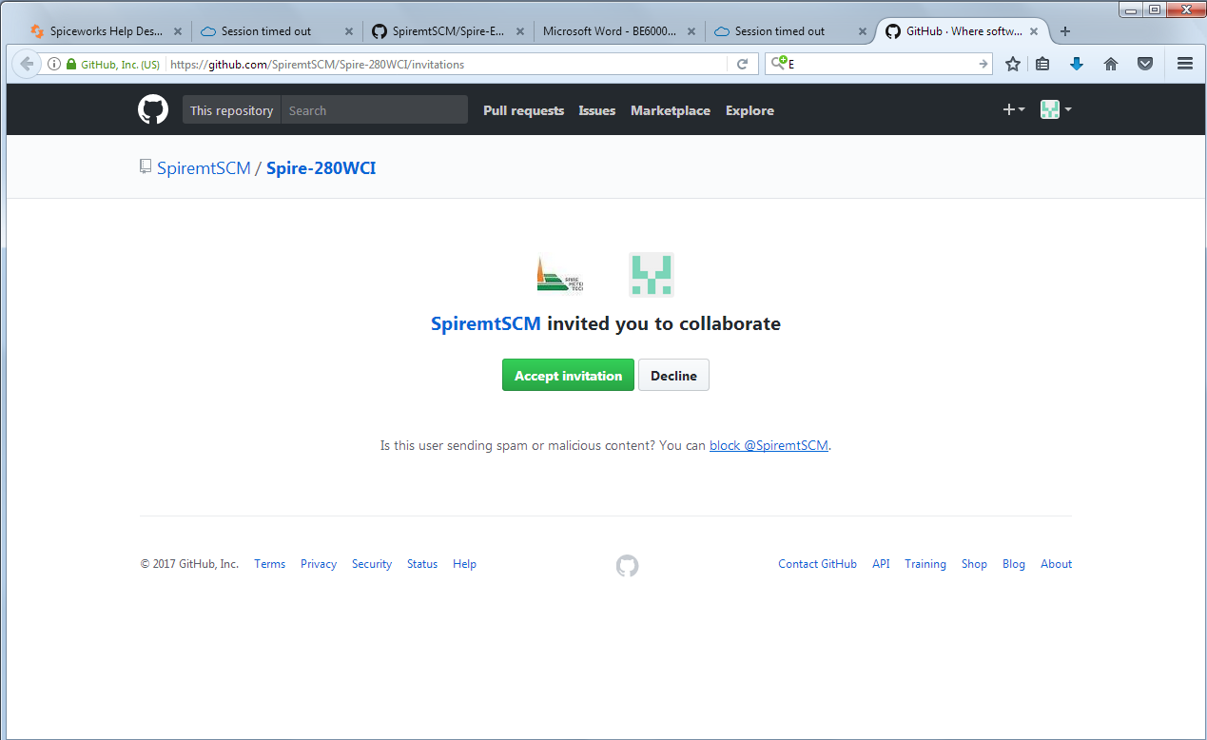

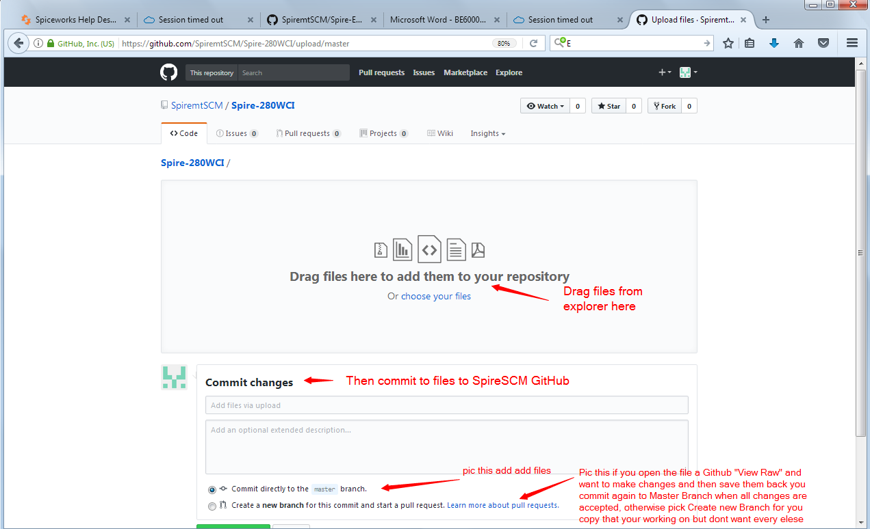



User Manuals

Technical Specifications

Technical Drawings

Latest Firmware

All datasheets into [**Spire-Product-Datasheets**](https://github.com/SpiremtSCM/Spire-Product-Datasheets)

All other that are specified above into the other Repositories below: Click on the link below

* [**Spire-EF10-TP10**](https://github.com/SpiremtSCM/Spire-EF10-TP10)

Spire EF10-TP10

* [**Spire-EF40**](https://github.com/SpiremtSCM/Spire-EF40)

Spire EF40

* [**Spire-EF12**](https://github.com/SpiremtSCM/Spire-EF12)

Spire EF12

* [**Spire-280T-S**](https://github.com/SpiremtSCM/Spire-280T-S)

Spire 280T-S

* [**Spire-280W-D--CI**](https://github.com/SpiremtSCM/Spire-280W-D--CI)

Spire 280W-D--CI

* [**Spire-280W-R**](https://github.com/SpiremtSCM/Spire-280W-R)

Spire 280W-R

* [**Spire-MAG888--Flowmeter**](https://github.com/SpiremtSCM/Spire-MAG888--Flowmeter)

Spire MAG888--Flowmeter

* [**Spire-MAG-888-DC**](https://github.com/SpiremtSCM/Spire-MAG-888-DC)

Spire MAG-888-DC

* [**Spire-T-MAG-BTU**](https://github.com/SpiremtSCM/Spire-T-MAG-BTU)

Spire T-MAG-BTU

* [**Spire-280T**](https://github.com/SpiremtSCM/Spire-280T)

Spire 280T

* [**Spire-280WR**](https://github.com/SpiremtSCM/Spire-280WR)

Spire 280WR

* [**Spire-280WCI**](https://github.com/SpiremtSCM/Spire-280WCI)

Spire 280WCI

Spire Product-Datasheets